EE3060 Probability – Proposed questions and answers

Question 1:

We roll a standard fair die over and over.

What is the expected number of rolls until the first pair of consecutive sixes appears? (Hint: The answer is not 36.)

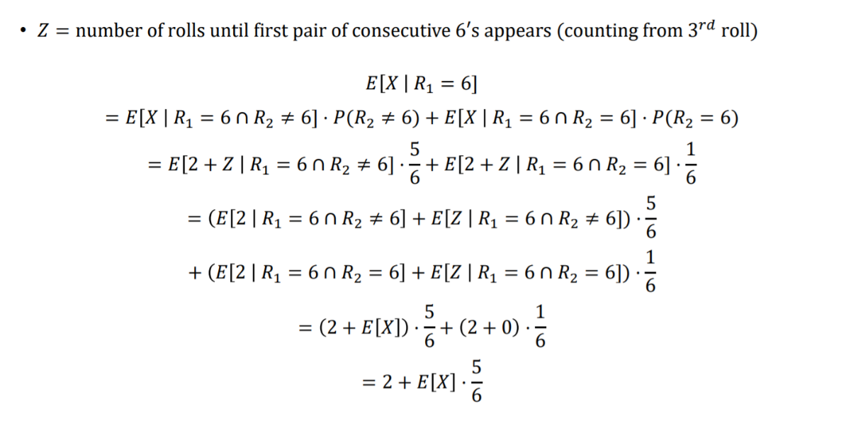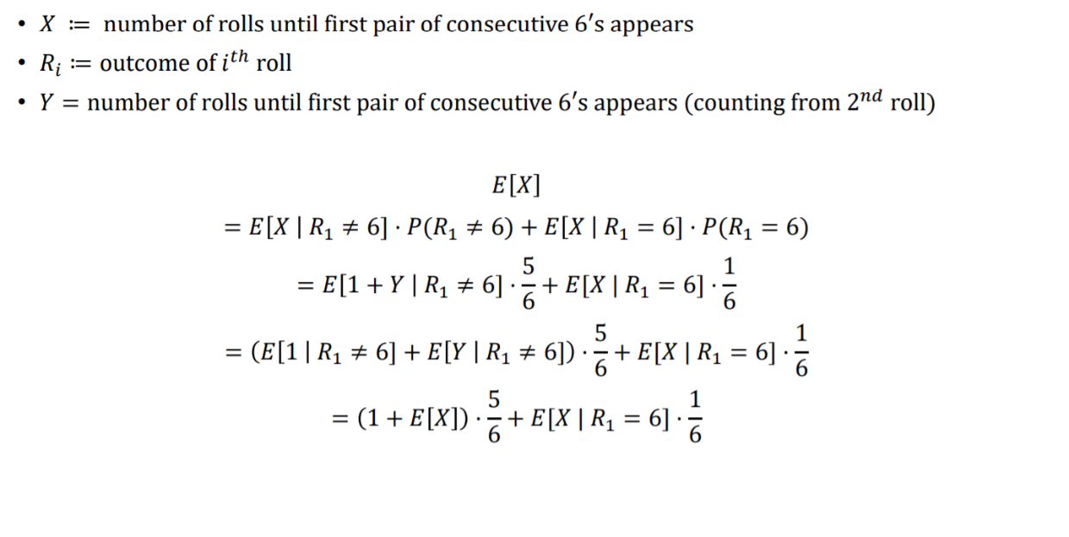Answer 1:

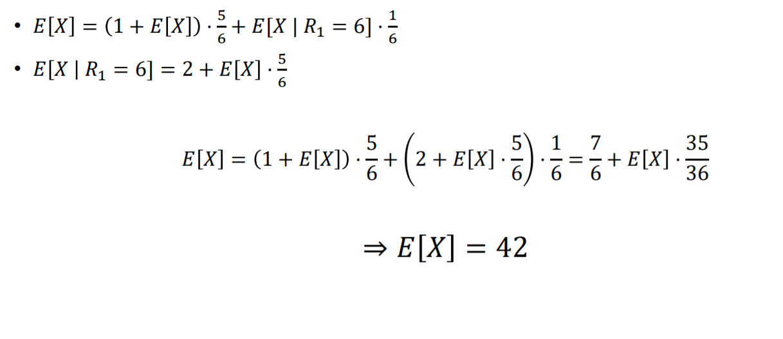

Question 2:

Let $X$ be a discrete random variable with the following PMF:

$$P_{X}\left(k\right)=\left\{\begin{aligned}0.2 for k=1 \\ 0.2 for k=2 \\ 0.5 for k=3 \\ 0.1 for k=4 \\ 0 otherwise\end{aligned}\right.$$

1. Find $E\left[X\right]$
2. Find $Var\left[X\right]$
3. If $Y={\left(X-2\right)}^{2}$, find $E\left[Y\right]$

Answer 2:

$E\left[X\right]=0.2*1+0.2*2+0.5*3+0.1*4=2.5$

$Var\left[X\right]=E\left[X^{2}\right]-{\left(E\left[X\right]\right)}^{2}$

$$E\left[X^{2}\right]=0.2*1^{2}+0.2*2^{2}+0.5*3^{2}+0.1*4^{2}=7.1$$

$$Var\left[X\right]=7.1-{2.5}^{2}=0.85$$

$E\left[Y\right]=E\left[{\left(X-2\right)}^{2}\right]=0.2{(1-2)}^{2}+0.2*{\left(2-2\right)}^{2}+0.5*{\left(3-2\right)}^{2}+{0.1*\left(4-2\right)}^{2}=1$

Question 3:

Consider two random variables X and Y with joint PMF given below

(A)Find P(X≤2,Y≤4).

(B)Find the marginal PMFs of X and Y.

(C)Find P(Y=2|X=1)

Y=2 Y=4 Y=5

X=1 1/12 1/24 1/24

X=2 1/6 1/12 1/8

X=3 1/4 1/8 1/12

Answer 3:

(a)

To find P(X≤2,Y≤4), we can write

P(X≤2,Y≤4)=PXY(1,2)+PXY(1,4)+PXY(2,2)+PXY(2,4)=1/12+1/24+1/6+1/12=3/8.

(b)

Note from the table that

RX={1,2,3} and RY={2,4,5}.

Now we can use Equation 5.1 to find the marginal PMFs:

PX(x)= 1/6 ,x=1

3/8, x=2

11/24, x=3

0, otherwise

PY(y)= 1/2, y=2

1/4, y=4

1/4, y=5

0, otherwise

(c)

Using the formula for conditional probability, we have

P(Y=2|X=1)=P(X=1,Y=2)/P(X=1)=PXY(1,2)/PX(1)=(1/12)/(1/6)=1/2.

Question 4:

There are five rabbit and three hole on the hill. Suddenly, the wolf come up, and the rabbits run to one hole to hide. Assume the probability of the hole chosen by rabbits are the same. What is the expectation of the hole which is empty?

Answer 4:

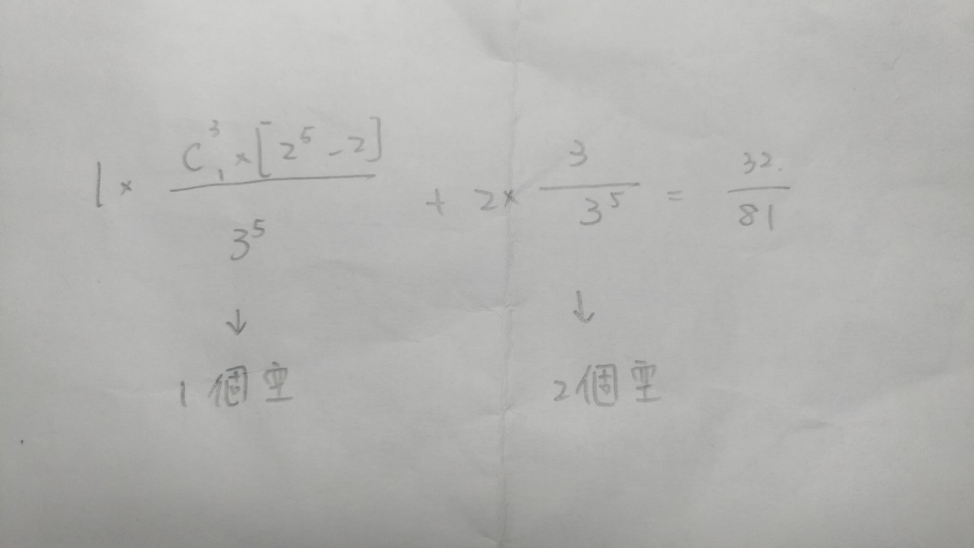

Question 5:

Find the variance of *X*, the random variable with probability mass fuction

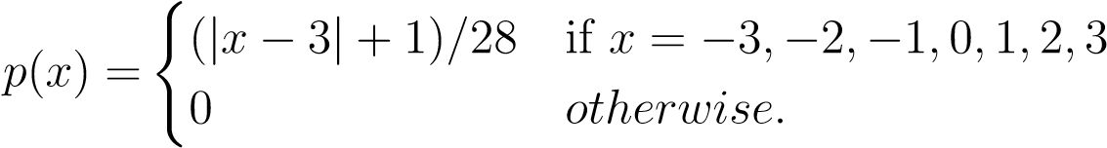

Answer 5:



*V ar*(*X*) = 4 − 1 = 3*.*